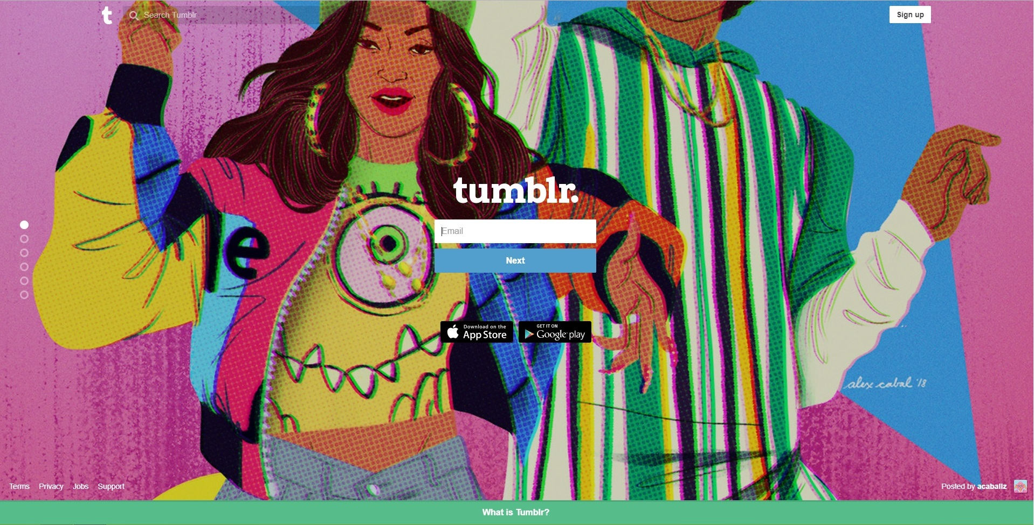
1. First page
This is the login screen. The
background tends to change and features
the original works from people's blogs.
Shows the owner of the featured work
Home button
You can search for content
around the website.
A brief explanation of
what the website is
all about.
Explains what the site is all about
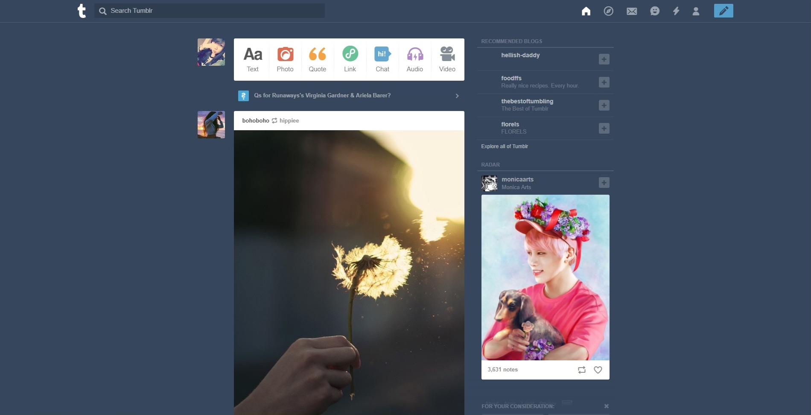
Second page
This is where you can
explore other blogs,
customize your own
blog, and share content.
This is the dashboard. Shows you
content that you and
other blogs have shared.
This button allows you to
share the person's work
Some shared content from other
blogs will be shown
in your dashboard
Some recommended blogs
Shows content from other blogs
that you might
be interested in.
This is where you
can post/share your
own content
This button allows you to
like another blog's work
2. First page
The home page of a Physics website
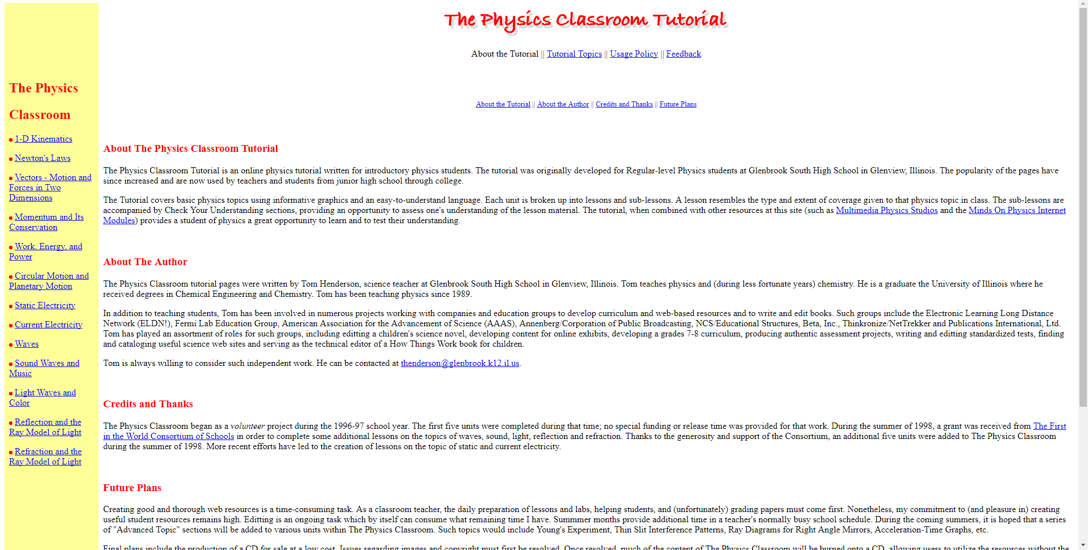
Content is very straight to the point. Has
way too much content
and can be very boring to
read. Not interactive.
It's too bright for some users.
Not really interactive. Seems plain.
The website has too many white spaces.
Too bright for some users.
Second page
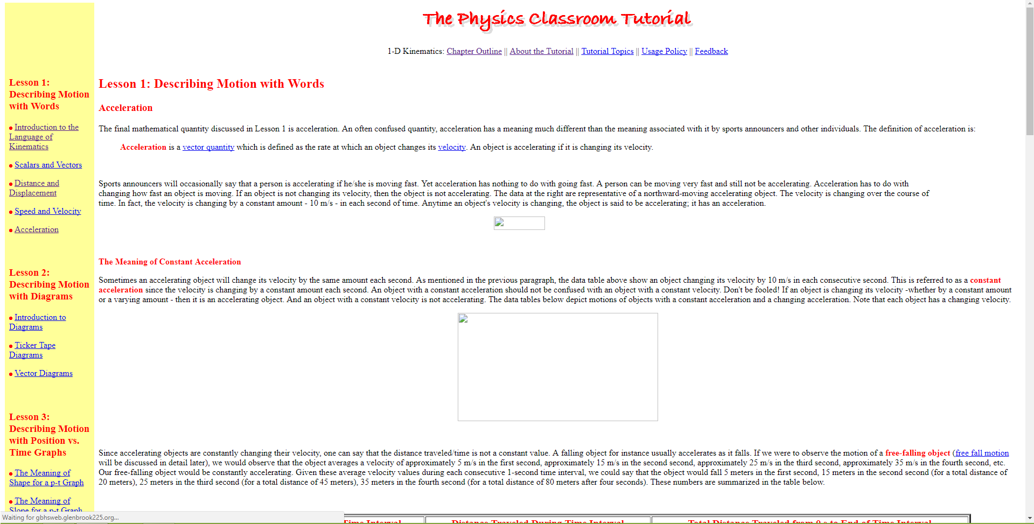
Has consistent format with side bar.
Head is also consistent
Has many white spaces
Too many things to read, it
can get boring for user.
- An example of a website would be online shops like the milkclub.storenvy.com. This particular site has a very aesthetic background. It does not have a lot of distracting or extra designs. It is also very organized and is pretty clean to look at.

- I think that websites that use unique navigation methods are effective towards people who appreciate the aesthetic-ness of the website. I think that this method is effective towards some people who enjoy interacting with websites and discovering information in a creative manner. But I also do not think this method would be very effective for people who prefer being straight to the point or, in other words, prefer the plain and organized method.

6. I tested Mozilla Firefox and Google. While visiting the sites I usually go to, I don't see any difference. And that they are basically the same and can keep up with performance.

7. Whenever I would hover over to other things too fast, I lose focus on what to listen to first. It was pretty annoying whenever I'd hover to another tab or click on something. I also feel like whenever something is being read, it's too fast to listen to. But I suppose this is helpful for other people.

